Name : T. Sri Vidhya
Degree : BTech - Computer Science & Engineering
College Name : Bharath Institute Of Higher Education & Research (BIHER), Chennai
Experience : No experience in Data Science
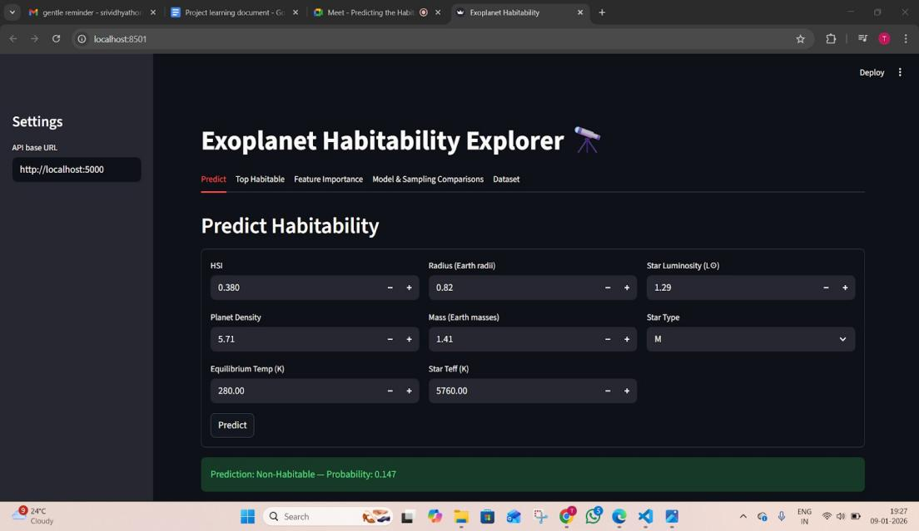

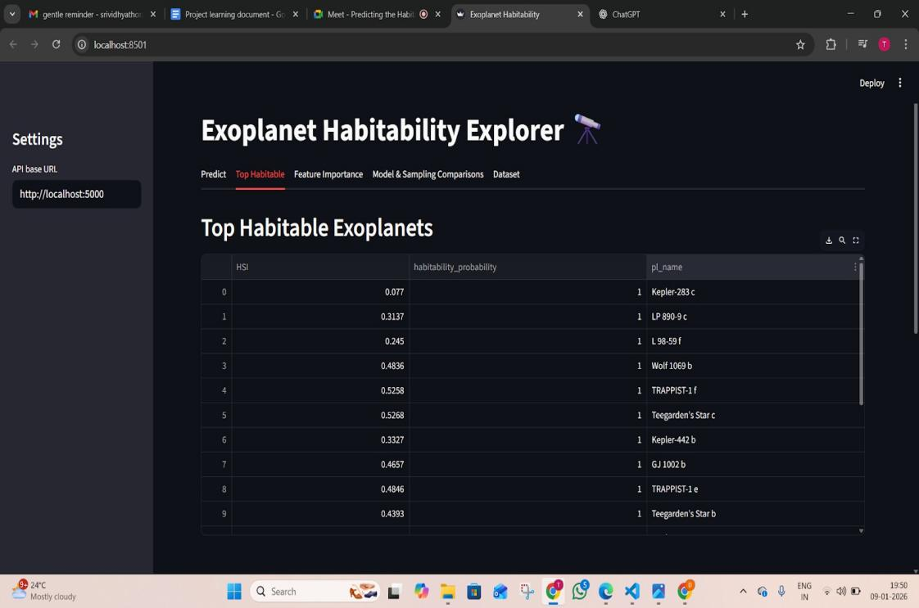

Milestone 1 – Completed
- Completed initial dataset understanding and documentation.

Milestone 2 – In Progress(Due to sem exams)
- GitHub repository has been created.
- Going through how to handle the imbalance dataset.
- Learnt concepts related to:
  - Feature Scaling
  - Normalization
  - PCA
  - Handling using SMOTE
  - Evaluation metrics : Precision, Recall, F1 score, confusion matrix
- Also understanding how models such as SVM n RF will be applied after preprocessing
- Code files will be developed once I clearly understand how to implement these steps
- I’ll be adding the code files to the repo once the implementation starts

Milestone 2 - Completed(2/1/26)
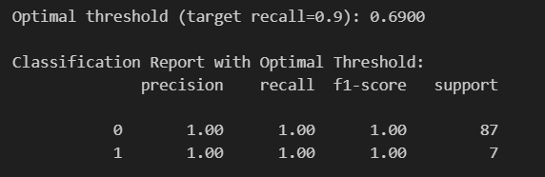
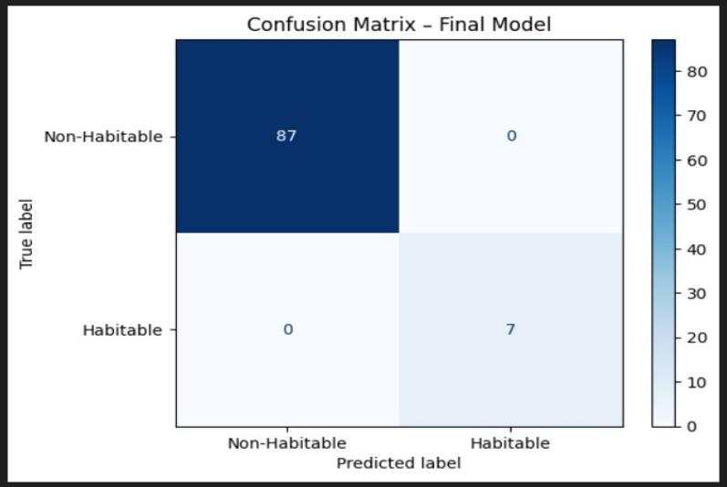

The best-performing model in my project is a Random Forest Classifier integrated with SMOTE inside a pipeline, as it achieved the best balance between recall, F1-score, and ROC-AUC while remaining interpretable and stable.

Module 1: Data Collection and Management

Week 1: Day 4 (4/12/25)

Dataset Link 1 - NASA Exoplanet Archive (Planetary Systems Composite Parameters – PSCompPars)
https://exoplanetarchive.ipac.caltech.edu/cgi-bin/TblView/nph-tblView?app=ExoTbls&co nfig=PSCompPars

My observations:
- Searched & identified multiple exoplanet datasets online.
- Collected NASA Exoplanet Archive dataset with ~40,000 rows and 90+ columns.
- Column names are abbreviated and need understanding
- Missing values present in important features
- Does not directly provide habitability label
- Data quality is reliable and regularly updated
- Selected as primary dataset

Week 1: Day 5(5/12/25)

- We discussed descriptive statistics, what’s the difference between percentage and percentile and also how percentile related to distribution.
- Need to analyse the descriptive statistics for available features in the dataset.

My observations:
- Reviewed problem statement & required features:
Planet radius, mass, density, surface temperature, orbital period, distance, star type, luminosity, metallicity.
- Cross-checked available features in NASA dataset.
- Noted that some features like distance might need transformation or derivation.
- Began creating a list of required vs available features.
- Planned feature filtering strategy.
- Noted data imbalance: many non-habitable vs few habitable

- Learned basics of habitability concept - why features matter
- Prepared questions for next steps: handling missing values, feature selection, etc.
- Got clarity on how cleaned data will later move into feature engineering (PCA, scaling, etc.).

Weekend:
- Loaded NASA dataset into Python using pandas and displayed the first few rows to inspect data structure.
- Used df.info() and df.describe().
- Checked percentage of missing values
- Removed non-informative columns
- Filtered obvious non-terrestrial planets
  - Radius > 5 Earth radii
  - Temperature > 1000 K
- Handled missing values
- Saved cleaned dataset

Module 2: Data Cleaning & Feature Engineering
Week 2: Day 2(9/12/25)
Analysed the research paper and learnt about the algorithms and concepts they have used in that
- lhtm
- /uploads/V3ISSUE2/ijrpr2746-detection-of-exoplanets-using-machine-learning.pd f
- https://arxiv.org/pdf/2011.14135
- https://www.kaggle.com/code/nickoreese/exoplanet-habitability-prediction

My observations:

- Studied feature engineering techniques from research papers
- Learned importance of feature extraction & sampling strategies.
- Read on SMOTE, class imbalance handling.
- Understood why recall is critical for imbalanced data
- Studied SMOTE and class-weight techniques
- Learned pipeline-based modeling
- Observed use of PCA & t-SNE for visualization
- Learned importance of interpretability
- Identified best practices from papers

Week 2: Day 3(10/12/25)

Created a Github branch and worked on preprocessing the data.

My Observations:
- Handled missing values using median
- Detected outliers using IQR
- Created derived features:
- Planet density
- Habitability Score Index (HSI)
- Stellar Compatibility Index (SCI)
- One-hot encoded star type flags (star_type_F/G/K/M).
- Normalized numerical features using StandardScaler.
- Verified data consistency
- Saved updated dataset

Week 2 : Day 4(11/12/25)

Task: Upload code files in the repo

My work:

- Worked on the project by continuing the preprocessing of the exoplanet dataset.
- Computed: df.describe(), box plots, class distribution.
- Identified outliers in certain numerical features.
- Identified mixed data types that require standardization.
- Listed columns for removal or transformation.
- Created histogram of key features (radius, mass, temp).
- Documented presence of imbalanced target distribution.

Progress:
- Generated descriptive statistics
- Plotted box plots for outlier detection
- Visualized class imbalance
- Created histograms for key features
- Generated correlation heatmap
- Observed strong relation of temperature & insolation
- Verified feature distributions
- Prepared dataset for modeling

Week 2: Day 5(12/12/25)
- Split cleaned dataset into train/test (80:20).
- Built Logistic Regression with class weights
- Built Random Forest with class weights
- Evaluated using:
- Precision
- Recall
- F1-score
- ROC-AUC
- Generated confusion matrices
- Observed low recall for minority class
- Identified need for imbalance handling
- Plotted confusion matrices.

- Compared ROC curves.

Week 3: Day 1
- Applied SMOTE on training set.
- Retrained Random Forest with SMOTE.
- Compared baseline vs SMOTE results
- Observed improvement in minority recall.
- Generated classification report.
- Compared ROC-AUC before/after SMOTE.
- Saved model outputs

Week 3: Day 2
- Combined scaling + SMOTE + model into pipeline.
- Evaluated pipeline performance.
- Demonstrated improved performance metrics.
- Conducted cross-validation using StratifiedKFold.
- Calculated mean ROC-AUC/CV scores.
- Tuned Random Forest parameters slightly.
- Validated stability of model

Week 3: Day 3
- Extracted feature importance:

Feature | Importance
pl_insol | 0.3344
pl_eqt | 0.2272
HSI | 0.1696
- Visualized importance using bar plots
- Interpreted model behaviour
- Visualized feature importance bar chart.

- Documented which features matter most.
- Plotted partial dependence

Week 3: Day 4
- Finalized best performing model.
- Tuned decision threshold based on PR curve.
- Generated precision-recall vs threshold graph.
- Determined threshold for best recall.
- Saved model + scaler + pipeline.
- Ranked top exoplanets by habitability probability.
- Identified top habitable candidates
- Completed model evaluation.

WEEK 3 CHECKPOINT:
- Completed data preprocessing steps such as handling missing values, removing outliers, and scaling numerical features.
- Performed exploratory data analysis to understand feature distributions, correlations, and the level of class imbalance in the dataset.
- Created important derived features:
- Planet density
- Habitability Score Index (HSI)
- Stellar Compatibility Index (SCI).
- Applied PCA and t-SNE mainly for visualization to observe how habitable and non-habitable planets are distributed.
- Built baseline machine learning models :
- Logistic Regression
- Random Forest.

Module 4: AI Model for Habitability Prediction

Week 4 - Day 1 : 22/12/2025

- Trained a Logistic Regression model with class weights to handle imbalance.

- Trained a Random Forest Classifier with class weights enabled.

- Evaluated both models using:

- Precision

- Recall

- F1-score

- ROC-AUC

- Generated classification reports and confusion matrices.

Observations:

- Baseline models showed high accuracy but low recall for the minority (habitable) class.

- Observed that accuracy alone is misleading for imbalanced datasets.

Week 4 - Day 2 : 23/12/25
To improve model performance for the minority class using resampling techniques.

Work Done:

- Applied SMOTE only on the training dataset to avoid data leakage.

- Retrained Random Forest Classifier using SMOTE-balanced data.

- Compared baseline vs SMOTE results using classification metrics.

- Observed improvement in recall and F1-score for habitable class.

Week 4 - Day 3 : 24/12/25
To build a robust and reusable modeling pipeline.

Work Done:

- Combined preprocessing and modeling steps into a single pipeline:

- Feature scaling

- SMOTE

- Random Forest Classifier

- Evaluated the pipeline using Stratified K-Fold cross-validation.

- Computed mean ROC-AUC scores across folds.

- Verified model stability and consistency across splits.

Week 4 - Day 4 : 25/12/25
No class ( Christmas Holiday)

Week 4 - Day 5 : 26/12/25

- Understand which features influence habitability predictions.

Work Done:

  - Extracted feature importance from Random Forest model.

  - Ranked features based on importance scores.

  - Identified key influencing features such as:

    - Insolation

    - Equilibrium temperature

    - Habitability Score Index (HSI)

    - Planet radius and density

  - Visualized feature importance using bar plots.

  - Used Partial Dependence Plots for selected features.

- Use the trained model to rank exoplanets by habitability likelihood.

Work Done:

  - Used predicted probabilities from the trained model.

  - Ranked exoplanets based on habitability probability.

  - Identified top candidate habitable exoplanets.

  - Validated rankings using domain expectations.

WEEK 4 CHECKPOINT
  - Prepared dataset for modeling and evaluation.

  - Built baseline and imbalance-aware models.

  - Applied SMOTE correctly within the training pipeline.

  - Evaluated models using appropriate metrics for imbalanced data.

  - Interpreted model behavior using feature importance.

  - Ranked exoplanets based on predicted habitability score

MODULE 5 : FLASK BACKEND API

WEEK 5 - DAY 1 : 29/12/25

Work Done:

  - Analysed confusion matrix in detail to understand:

    - True Positives (correctly predicted habitable planets)

    - False Negatives (missed habitable planets)

  - Focused specifically on minority class errors, since habitability prediction prioritizes recall.

  - Compared predictions of baseline model vs SMOTE-based pipeline for the same test samples.

  - Investigated cases where the model produced high probability scores for non-habitable planets.

Observations:

  - SMOTE-based pipelines significantly reduced false negatives.

  - Model errors were mostly near decision boundary cases.

  - Predictions aligned with physical expectations for most samples

Week 5 - Day 2 : 30/12/25
Ensure that final model results are stable, consistent, and reliable.

Work Done:

  - Re-ran training and evaluation pipeline multiple times to check result consistency.

  - Verified that feature importance rankings remain stable across runs.

  - Compared ROC-AUC and recall values across different random seeds.

  - Checked that feature scaling and SMOTE steps behave consistently within the pipeline.

  - Reviewed final feature list to ensure no redundant or misleading features are included.

Observations:

  - Model performance metrics remained stable across multiple runs.

  - Feature importance rankings showed minimal variation.

  - Pipeline structure ensured reproducibility of results.

WEEK 5 - Day 3 : 31/12/25

No class (New Year Holiday)

WEEK 5 - Day 4 : 1/1/26
No class (New Year Holiday)

WEEK 5 - Day 5 : 2/1/26
Understand how a trained machine learning model can be accessed through a backend service.

Work Done:

  - Reviewed Module 5 requirements from the project document:

    - Accept exoplanet data as input

    - Return habitability prediction and probability

    - Use JSON-based communication

  - Studied the concept of REST APIs and HTTP methods (GET, POST).

  - Designed a simple API flow:

    - Client sends planetary and stellar parameters

    - Backend processes input using trained ML pipeline

    - API returns prediction results

  - Identified required input features based on the final model (model.ipynb).

Learning Outcomes:

  - I learned the basics of REST architecture.

  - Understood why ML prediction APIs should use POST requests.

  - Gained clarity on separating backend logic from model training.

MODULE 6: Frontend UI Development

WEEK 6 - Day 1 : 5/1/26
Prepare the trained model for backend integration.

Work Done:

  - I focused on connecting the trained machine learning model with a frontend interface through a backend API.

  - Reviewed the final model.ipynb and identified:

Final selected features
Preprocessing steps required during inference Best-performing model to be used for deployment
  - Finalized the Flask REST API for habitability prediction.
  - Verified that the trained model (model.pkl) loads correctly at runtime.
  - Studied how trained models are serialized using joblib.

Ensured that the API returns:

  - Habitability class (Habitable / Non-Habitable)

  - Habitability probability score.

Observations:
  - Understood the importance of separating training logic from inference logic.

  - Ensured that preprocessing steps used during training are consistently applied during prediction.

  - Learned how incorrect feature ordering or missing features can break inference.

WEEK 6: Day 2 : 6/1/26
I implemented the backend REST API using Flask.

  - Created a Flask application (app.py).

  - Loaded the trained model using joblib.

  - Defined a /predict endpoint that:

    - Accepts JSON input

    - Extracts planetary and stellar parameters

    - Applies necessary preprocessing

    - Returns prediction and probability

  - Added a basic root endpoint to confirm API health.

Observations:

  - Learned how Flask handles HTTP requests and JSON payloads.
  - Understood common API errors such as:
    - Method not allowed
    - Feature mismatch
    - Missing inputs
  - Learned to debug API responses using terminal logs.

Outcome:
  - Backend API successfully running on http://localhost:5000.

  - Prediction endpoint responding correctly to requests.

WEEK 6: Day 3( 7/1/26)

I focused entirely on testing and validating the backend API.

  - Tested the /predict endpoint using:

    - Postman

    - Browser-based requests

  - Verified that:

    - API accepts valid numerical inputs

    - Outputs include prediction label and probability

  - Fixed issues related to:

    - Incorrect request methods

    - Feature mismatch errors

  - Confirmed model stability across multiple test cases.

Outcome:
  - Backend API confirmed to be stable and reliable.

  - Ready for frontend integration.

WEEK 6: Day 4 (8/1/26)
I worked on building the prediction interface for users.

  - Designed a clean UI titled “Exoplanet Habitability Explorer”.

  - Implemented input fields for key features:

    - Habitability Score Index (HSI)

    - Planet Radius

    - Planet Mass

    - Planet Density

    - Equilibrium Temperature

    - Star Effective Temperature

    - Star Luminosity

    - Star Type (F/G/K/M)

  - Connected the frontend to the Flask backend using the API base URL.

  - Implemented the Predict button to send inputs and display results.

Observations:

  - Learned how frontend inputs must strictly align with backend expectations.

  - Understood how API responses are parsed and rendered on the UI.

  - Realized the importance of default values for usability.

Outcome:
  - Prediction interface completed.

  - Users can input parameters and get real-time habitability predictions.

WEEK 6: Day 5(9/1/26)
Focused on validating outputs and analyzing system behavior.
  - Tested multiple combinations of input parameters:

    - Earth-like values

    - Extreme values

  - Observed changes in prediction probability based on:

    - Temperature

    - Density

    - Stellar parameters

  - Verified that predictions are logically consistent.

  - Refined UI layout and output readability

Observations:
  - Observed that small changes in key features significantly affect habitability prediction.
  - Feature importance visualizations not yet implemented
  - Model comparison and dataset visualization pending

WEEK 7: Day 1(12/1/26)

Day 1: Understanding Visualization Requirements & Planning
  - Reviewed the objective of Module 7 and identified the types of visualizations required.

  - Listed the important plots to be created:

    - Feature importance plots

    - Habitability score distribution

    - Star–planet parameter correlation plots

  - Decided which libraries to use for visualization (matplotlib, seaborn, and plotly).

  - Identified the dataset and model outputs needed for visualization.

Observations:

  - Visualization is important to explain model behavior clearly.

  - Some plots are more useful for interpretation than raw metrics.

  - Feature importance and score distribution are critical for decision-making.

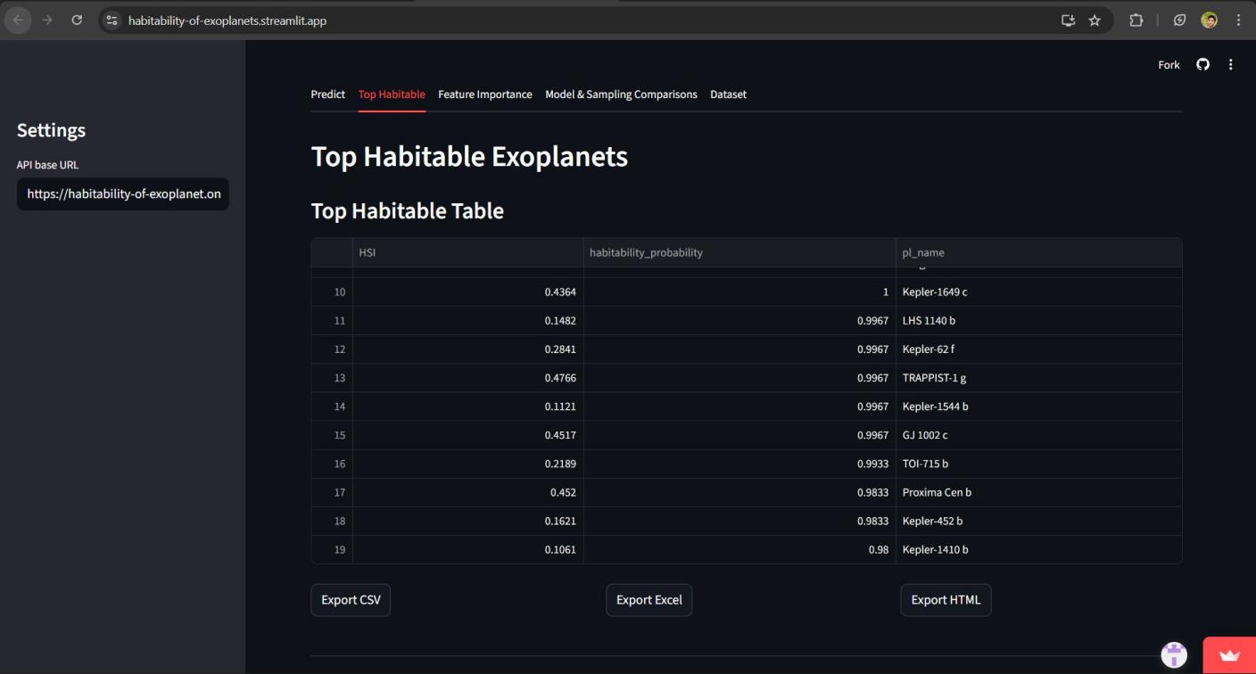

WEEK 7 : DAY 2(13/1/26)

Day 2: Feature Importance Visualization

Work Done:

  - Extracted feature importance values from the trained Random Forest model.

  - Created bar plots to show the importance of each feature.

  - Highlighted top features influencing habitability prediction.

  - Adjusted plot labels, titles, and scales for better readability.

Observations:

  - Temperature and insolation-related features have high influence.

  - Visual representation makes model decisions easier to understand.

  - Bar plots clearly show which features matter the most.

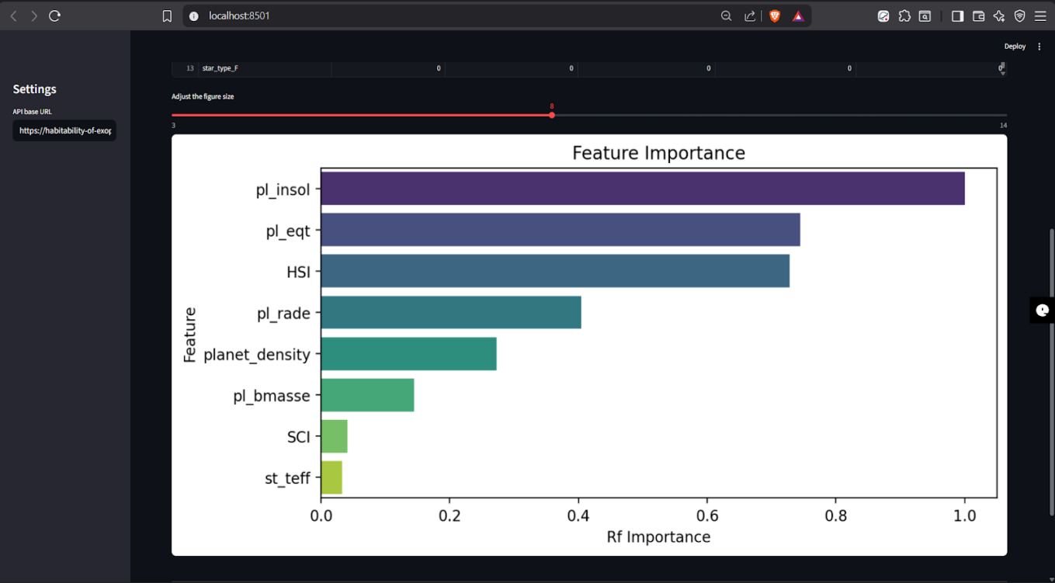

WEEK 7: DAY 3 (14/1/26)

Day 3: Habitability Score Distribution Analysis

Work Done:

  - Plotted the distribution of habitability probability scores.

  - Compared score distribution between habitable and non-habitable planets.

  - Used histograms and density plots for better clarity.

  - Analyzed how confidently the model separates the two classes.

Observations:

  - Most planets have low habitability scores, showing class imbalance.

  - Habitable planets tend to have higher probability values.

  - Score distribution helps in selecting a suitable decision threshold.

WEEK 7 : DAY 4 (15/1/26)

Day 4: Star–Planet Parameter Correlation Visualizations

Work Done:

  - Generated correlation heatmaps between planetary and stellar features.

  - Visualized relationships such as:

    - Star temperature vs planet equilibrium temperature

    - Insolation vs habitability score

  - Used seaborn heatmaps and scatter plots.

Observations:

  - Strong correlations exist between temperature-related parameters.

  - Some stellar features indirectly influence habitability.

  - Correlation plots help validate scientific reasoning behind the model.
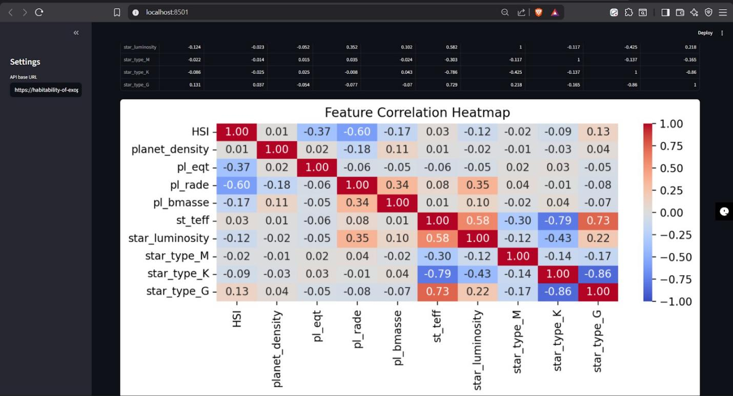

WEEK 7: DAY 5 (16/1/26)

Day 5: Interactive Dashboard & Visualization Integration

Work Done:

  - Used plotly for interactive charts where applicable.

  - Integrated visualizations with the frontend or notebook dashboard.

  - Ensured charts update correctly based on selected data.

Observations:

  - Interactive plots improve user understanding and engagement.

  - Dashboard format makes analysis more intuitive.

  - Combining multiple plots gives a complete picture of habitability.

WEEKEND: Report Export & Final Validation

Work Done:

  - Identified top candidate exoplanets based on habitability scores.

  - Exported results and rankings to Excel format.

  - Generated visual reports for documentation purposes.

  - Verified accuracy and consistency of visual outputs.

Observations:

  - Exported reports are useful for further analysis and sharing.

  - Visualization supports model predictions effectively.

  - Module 7 successfully improves interpretability and usability of the system.

Module 8: Deployment & Documentation
(Render)

WEEK 8: DAY 1 (19/1/26)

Day 1: Deployment Planning using Render and Streamlit

Work Done:

  - Reviewed project deployment requirements.

  - Selected Render as the deployment platform.

  - Studied how Flask applications are deployed on Render.

  - Checked required files such as requirements.txt and start command.

  - Planned environment setup for backend deployment.

Observations:

  - Render provides simple deployment for Flask applications.

  - Deployment requires proper configuration files.

  - Understanding platform workflow helps avoid errors.

Preparing Flask Application for Render

Work Done:

  - Updated Flask app to support production deployment.

  - Verified that the application runs correctly using a production server.

  - Ensured trained model files are included in the project directory.

  - Tested API endpoints locally before deployment.

Observations:

  - Local testing reduces deployment failures.

  - Missing files can break deployment.

  - Production environment behavior differs from local setup.

Environment Variables & Database Handling

Work Done:

  - Configured environment variables in Render.

  - Verified database or CSV-based data access in the deployed environment.

  - Ensured file paths work correctly in cloud deployment.

  - Tested data access through the backend API.

Observations:

  - Environment variables improve security.

  - File path handling is important in cloud platforms.

  - Database integration works differently in deployed systems.

Deploying Application on Render

Work Done:

  - Deployed the Flask backend on Render.

  - Generated a public deployment URL.

  - Tested /predict API endpoint on the live server.

  - Fixed deployment errors using Render logs.

Observations:

  - Render logs are helpful for debugging.

  - Deployment issues can be identified quickly using logs.

  - Successful deployment confirms backend stability.

Here is the link for backend https://habitability-of-exoplanet.onrender.com/
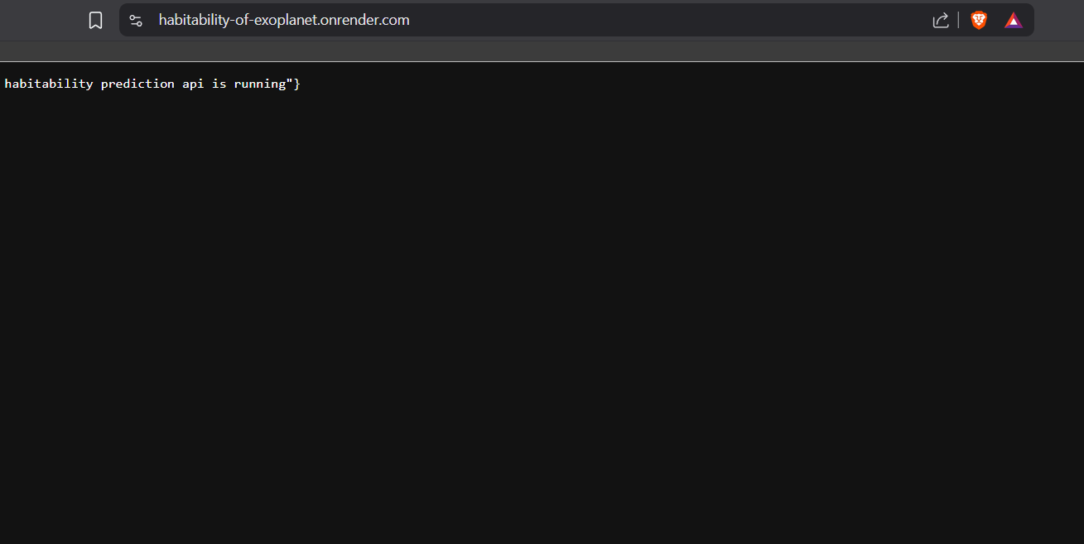

Deploying Frontend Application using Streamlit

Work Done:

● Developed the frontend using Streamlit for user interaction
.
● Integrated the trained machine learning model with the Streamlit app.

● Created input fields for planetary and stellar parameters.

● Displayed habitability prediction and probability output on the UI.

● Tested the Streamlit application locally and in deployed mode.

Observations:

● Streamlit makes frontend development simple and fast.

● UI updates automatically when inputs are changed.

● Easy integration of machine learning models with minimal code.

● Streamlit is suitable for demonstrating ML applications effectively.
here is the link for frontend https://habitability-of-exoplanets.streamlit.app/

Day 2: (20/1/26)

Work Done:

  - Prepared full technical documentation of the project.

  - Created a README file including:

    - Project overview

    - Technology stack

    - Setup instructions

    - API usage

    - Deployment details (Render)

  - Added screenshots of the deployed application.

Observations:

  - Clear documentation improves project understanding.

  - README is essential for GitHub projects.

  - Deployment details add technical credibility.

